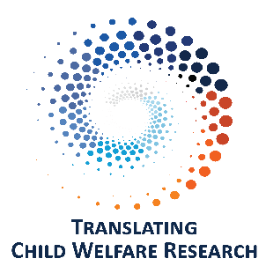

# Translating Child Welfare Research Podcast Introduction

# Transcript of Episode 0

## Dr. Robin LaSota

Welcome to the Translating Child Welfare Research podcast.

I'm Robin LaSota, and I'm here with Heather Fox. Together, we’re co-producing this podcast. We work in Translational Research at the School of Social Work at the University of Illinois Urbana-Champaign. Our goal today is to provide you with a brief overview of this podcast, including its goal and vision.

There is an increasing call for the implementation of evidence-based practices in child welfare. However, those working in child welfare often do not have direct access to research or the time necessary to translate complex research studies into practical applications. In this podcast, we hope to provide a bridge between child welfare researchers and child welfare practitioners.

## Dr. Heather Fox

Every month, we invite a child welfare researcher from across the United States to discuss an emerging finding from their research. They share how what they have learned translates to support effective and equitable child welfare practice with the goal of improving outcomes for the children, youth, and young adults we serve. These interviews will be brief, but we will provide additional materials on our website for those interested. Each episode will be independent, so you can choose the topics that interest you, or listen to each episode in turn. We are interested in your feedback and ideas of topic areas to cover. If you have ideas or would like to be a guest, Contact us at DCFS.ORCW@illinois.gov.

The University of Illinois Urbana-Champaign School of Social Work is providing the content of this podcast series, with funding and support by the Illinois Department of Children and Family Services. The views, thoughts, and opinions expressed in this podcast are the speaker’s own and do not represent the views, thoughts, and opinions of the University of Illinois or the Illinois Department of Children and Family Services. The material and information presented here is for general information purposes only and do not imply endorsement, of or opposition to any specific organization, product, or service.